

How to get ICP-Base running

Compiled version
- If the filename of the install-file (.exe) is NOT ending in “_mcr” you need internet access to download the MATLAB Runtime library. So you need internet access to run ICP-Base.
- If the filename is ending with “_mcr” you do not need internet access since the Runtime Library is already included and you can install ICP-Base on any computer, even without internet access. This file is therefore also much larger in memory.
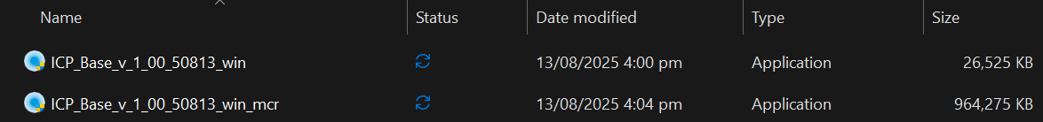
Simply double-click the install-file (e.g. ICP_Base_v_1_XX_XX.exe) and the installation process starts.
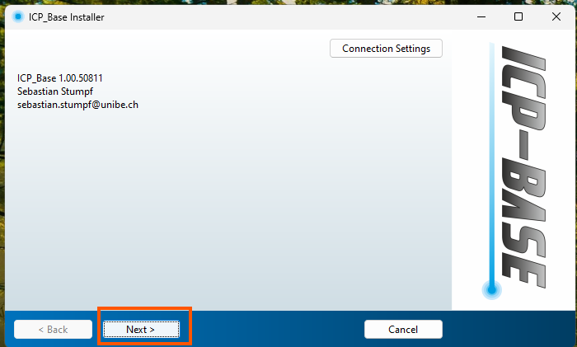
Click “Next >”.

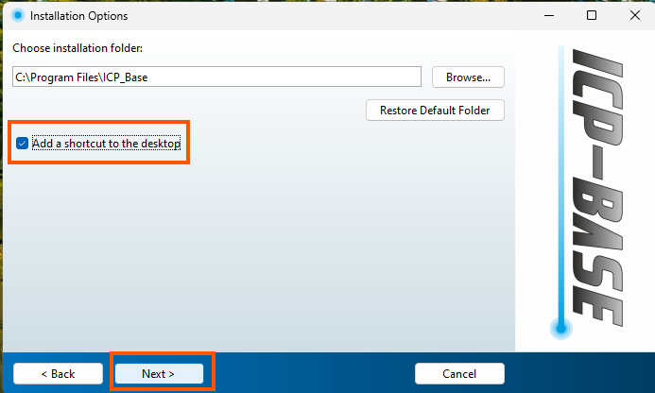
I would recommend to add a shortcut to the desktop. Also make sure to remember where ICP-Base installation folder is located because you might want to access it later to customize your plots and reference material files!
Then click “Next >”.
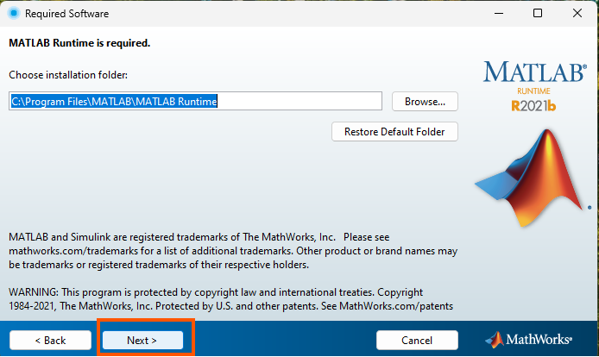
If you do not have the Runtime library already installed, MATLAB will do that for you. Just click “Next >”.
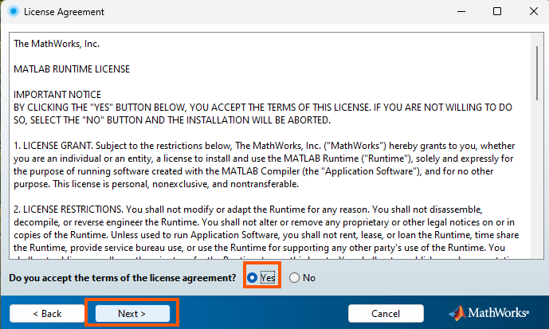
Agree and click “Next >”.

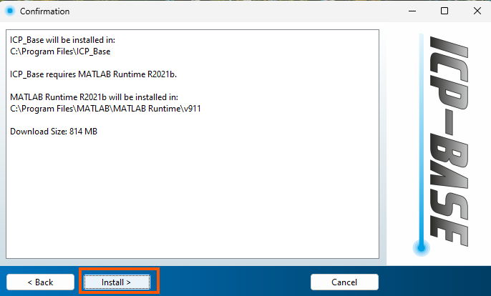
Click “Install”.
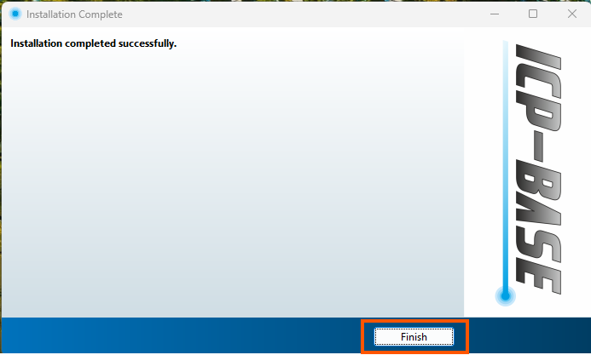
You did it! Click “Finish” and the shortcut icon (if selected above) should show up on your desktop. Now start ICP-Base by double-clicking the shortcut icon. This can take some time since MATLAB initializes the graphical user interface for the first time.
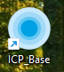
In the installation folder “ICP_Base > application”, you will find subfolders including “RM_Files” and “Plot_Styles” which can be important depending on your use case.
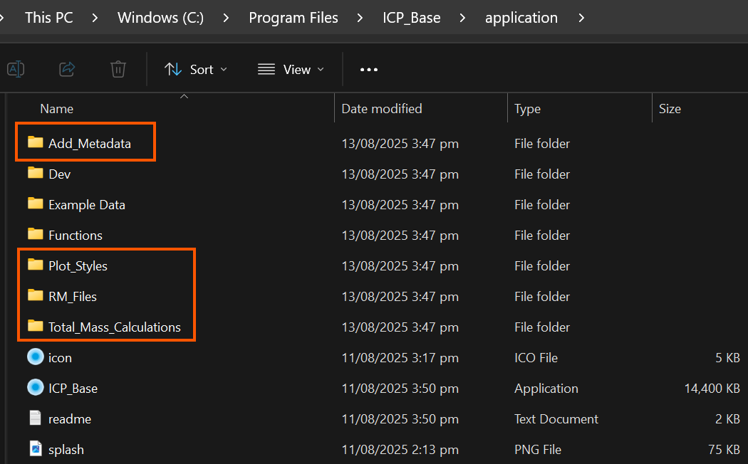

Uncompiled version
If you choose to run it uncompiled, make sure to have MATLAB and the MATLAB App Designer with a valid license. Ideally you use the MATLAB 2021b version since this is the same version the software was programmed in initially. Bugs can occur if you use a newer version.
When installing MATLAB make sure to add the Add-Ons “Image Processing Toolbox” and “Statistics and Machine Learning Toolbox”.
If your MATLAB is already set up but those Add-Ons are not installed you can get them using the “Add-Ons” Button in the “Home” Tab.
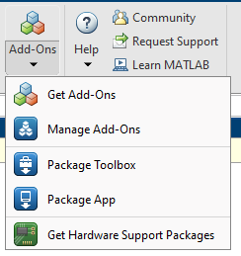
Once your MATLAB is running, navigate the path to the folder in which ICP-Base is stored. Then right-click the folder and selected “Add to Path” followed by “Select Folders and Subfolders”.
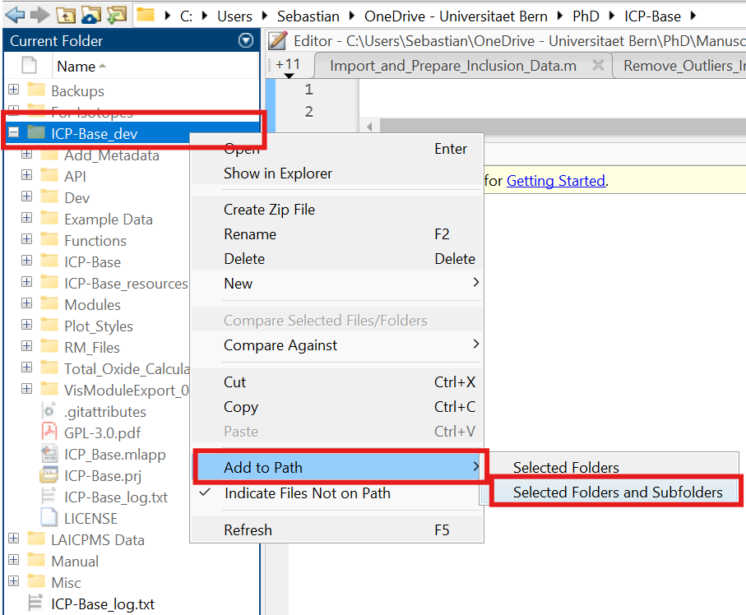
The folders are then not greyed out anymore:
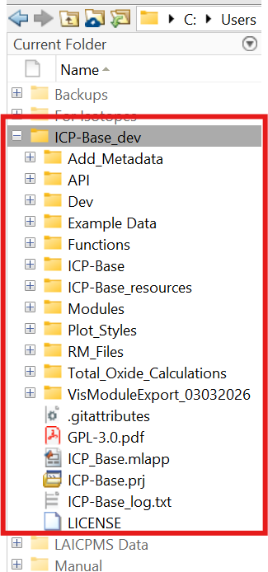
Next, either right-click on ICP_Base.mlapp and press “Run” to open it directly or double-click on it to open ICP-Base in the App Designer. Once ICP-Base is open in the App Designer, go to the “Editor” or “Designer” Tab and then press the “Run” button.

